2016

**Samuel Murani**

**J17/0492/2012**

3/19/2016



**Kenyatta University**

**Department of Computing and**

**Information Technology**

**SCO400: PROJECT**

**Title: iProject (internet Based Project Management System)**

**Project Supervisor: Mr. Duncan Kibui**

iProject Management System

# DEDICATION

This project report is dedicated to:

* My Parents ………………………………………
* My Siblings …………………………………………
* My Supervisor ……………………………………..
* My Friends ……………………………………..
* Kenyatta University

You all played a role in helping me do my project and also write this report and come this far. Above all, I thank the almighty God for the guidance and protection throughout the project development process.

# ABSTRACT

Project Management is a complex area that involves developing a project plan, which includes defining and confirming the project goals and objectives, identifying tasks and how goals will be achieved, quantifying the resources needed, and determining budgets and timelines for completion. In situations where a single manger or supervisor is managing many projects at a time, it becomes hard to keep track of the project documents, communications and keep track of each student or developer. Due to this problem, iProject management system was developed to address this issue and provide an easier way to oversee the project management process.

iProject System has two main modules, admin module and the normal user module. Below these two main modules, each has its own modules to enhance the functionality and duties needed to be carried out by each person. A users who can be a student or a developer, defines his/her project details, and sends documents to the project manager who is the supervisor. There are other functionality in the system such as milestones definition, task definition, notices and emails that enhance the project management process so as to ensure that everything is working well.

The admin section of the project allows the system admin to manage projects. The admin is able to view the project details input by the students, documents attached and emails sent. The notices section of the project allows the admin to broadcast important notices to every system users. This section also has a report generation module which allows the supervisor to be able to generate project reports for filing.

This report summarized the work carried out in the development of the iProject system, since the start to the end. It gives details about the system analysis, design, implementation, and the report output generated by the system. In the appendices, there is a user manual which explains how to install and run the system, how to sign up and configure the system in order to enjoy the full benefits.

# ACKNOWLEDGEMENT

Despite all the toil and effort I have put into this project, developing the system and putting this paper together would not have been possible without the help of many individuals.

I would like to take this opportunity to thank Mr. Duncan Kibui, my project Supervisor at Kenyatta University who has guided me throughout the project development process and report writing. He has helped me learn the basic procedures required to develop a system.

I remain grateful to Software Technology Limited, who took me in for attachment and equipped me with the skills to develop real world applications that solve people’s problems.

Finally, I would like to extent my heartfelt gratitude to my family members especially my mother and my sister, classmates and other friends for their invaluable support (moral and otherwise) throughout my project development process. My classmates, Steve, Cyrus, Reuben, Kanja and Muthuri, played a big role in testing the iProject Modules so as to ensure the system works well.

God bless you all.

# DECLARATION

I, **SAMUEL NDIVA MURANI**, hereby declare that this project report is my original work and it has not been submitted before for any academic award either in this or other institutions of higher learning for academic publication or any other purpose. The references used here from other journals or materials are indicated in the references section.

Signature: …………………….

**SAMUEL NDIVA MURANI**

Date…………/…………/ 2016

# Table of Contents

DEDICATION ii

ABSTRACT iii

ACKNOWLEDGEMENT iv

DECLARATION v

Table of Contents vi

List of Tables ix

List of Figures x

CHAPTER ONE 1

**INTRODUCTION** 1

**1.0 Background of the study** 1

**1.1 Problem statement** 2

**1.2 Objective** 2

**1.3 Scope and Limitations of the study** 2

**1.4 Justifications** 3

CHAPTER TWO 5

**LITERATURE REVIEW** 5

**2.1 Introduction** 5

**2.2 Theories and Basics behind Projects and Project Management Systems** 5

**2.3 History of Project Management** 6

**2.4 Project Management Software** 9

**2.5 Organizational Needs** 10

**2.6 Benefits of Project Management** 12

**2.7 Limitations of Project Management Systems** 13

**2.8 Requirements for a Project Management Software** 14

**2.9 Recommendations** 16

CHAPTER THREE 17

**METHODOLGY** 17

**3.1 Agile Methodology** 17

**3.2 Scrum management** 17

**3.3 Scrum development** 18

**3.4 Strengths of agile methodology** 19

**3.4 Weakness of agile methodology** 19

**3.6 Data Collection Methods** 19

**3.7 Tools that will be used to Implement and Test the System were as follows with a detailed review of the tools in chapter four;** 20

**3.8 Data Analysis and Process Tools** 20

**Time Schedule** 20

CHAPTER FOUR 22

SYSTEM ANALYSIS AND REQUIREMENT MODELING 22

**4.1 Introduction** 22

**4.2 Feasibility Study** 25

**4.3 Cost Benefit Analysis** 25

**4.4 Fact Findings** 27

**4.5 Requirement definition and Modelling of the Current system** 27

**4.6 Requirement definition and specifications of the proposed** 29

CHAPTER FIVE 33

SYSTEM DESIGN 33

**5.1 File and data Store Design** 33

**5.2 Input Design** 35

**5.3 Database design** 38

**5.4 Output Design** 43

CHAPTER SIX 45

SYSTEM IMPLEMETATION 45

**6.1 Tools used for implementation** 45

**6.2 Testing of iProject Management System** 48

**6.3 Change over Technique** 49

CHAPTER SEVEN 50

LIMITATIONS, CONCLUSION AND RECOMMENDATIONS 50

**7.1 Limitations** 50

**7.2 Recommendations** 50

**7.3 Conclusion** 51

References 52

Appendix 1: User Manual 55

Appendix 2: Project Cost (Budget) 59

Appendix 3: Time Schedule 60

Appendix 4: System analysis and requirement modelling symbols. 60

Appendix 5: Sample database tables 61

Appendix 6: Some important source code for iProject. 63

Appendix 7: Installation Manual 68

# List of Tables

Table 1: History of Project Management 8

Table 2: Project Time Plan 21

Table 3: Cost Incurred to develop the iProject system 26

Table 4: Benefits the iProject system is expected to yield 26

Table 5: Student Table 33

Table 6: Supervisor Table 33

Table 7: Admin Table 34

Table 8 Project Table 34

Table 9: User profile Table 34

Table 10: Documents Table 34

Table 11: Emails Details 34

Table 12: Task Details 35

Table 13: Milestones Details 35

Table 14: Student Relation Structure 38

Table 15: Supervisor Relation Structure 39

Table 16: Admin Relation Structure 39

Table 17: Project Relation Structure 39

Table 18: Document Relation Structure 40

Table 19: User Profile Relation Structure 40

Table 20: Email Relation Structure 40

Table 21; Milestone Relation Structure 41

Table 22: Tasks Relation Structure 41

Table 1. Gantt chart 59

# List of Figures

Figure 1: Scope Triangle 6

Figure 2: Components of Project Survival 8

Figure 3: Agile process Release 17

Figure 4: Scrum process 18

Figure 5: Context diagram for project management process 23

Figure 6 Flow chat for project management process 23

Figure 7: DFD for project management process 24

Figure 8: Document flow for project management 28

Figure 9: iProject Context Diagram 29

Figure 10: iProject Flow Chat Diagram 30

Figure 11: iProject Level 1 DFD 31

Figure 12: iProject Use Case Diagram 32

Figure 13: Student Registration form 35

Figure 14: Supervisor Registration Form 36

Figure 15: Project Registration Form 36

Figure 16: Project Document upload 37

Figure 17: User Profile update Form 37

Figure 18: Task Input Form 38

Figure 19: ERD Diagram 42

Figure 20: Project Report 43

Figure 21: System Users 43

Figure 22: Documents Report 44

# CHAPTER ONE

## **INTRODUCTION**

### **1.0 Background of the study**

(Commerce, 2014), Defines Project Management as a careful planned and organized effort to accomplish a successful project and a Project is a onetime effort that produces a specific result. Project Management has been a problem to many students, companies and educational institutions. The Processes involved in project management are many and ignorance of the processes can lead to poor deliverables and poor quality of projects. There exist different projects which are carried out in organizations and each of them has a different project of managing them. Software Projects follow specific stages and each stage has a deliverable.

The process of Project Management includes developing a project plan, which includes defining and confirming the project goals and objectives, identifying tasks and how goals will be achieved, quantifying the resources needed, and determining budgets and timelines for completion. It also includes managing the implementation of the project plan, along with operating regular 'controls' to ensure that there is accurate and objective information on 'performance' relative to the plan, and the mechanisms to implement recovery actions where necessary. Despite the major phases having different titles, the major phases involved in project management are feasibility, definition, project planning, implementation, evaluation and support/maintenance (Dinsmore, 2014).

In order to make the process of project management easy, a project management software is needed which would track the processes of software development among the developers and allow them to interact as they are still developing their projects.

iProject Management System is the proposed system that will aid developers especially in institutions to be able to manage their tasks and work as per the time schedule that they have prepared. The proposed system will be web based so as to allow developers from different parts of the country and world to be able to interact and help each other in developing and debugging the projects. The system will also allow project supervisors to be able to see the progress that students and developers will be making without having to meet up with them in cases where they are far. This will ensure effective project management and interaction between the participants in the project management.

### **1.1 Problem statement**

Considering the current Project Management and supervision in learning institutions and companies where individuals have to write proposal papers then wait for the supervisors to approve them and then make endless visits so that the supervisors can approve the work they are doing, the processes are tedious and time consuming. A case of an institution like Kenyatta University, students are assigned supervisors who are at times not always in school. This has been making it hard for students to get in touch with them so that the supervisors can see and approve their work. Almost everything is done in paper work and this increases the risks of papers getting lost.

In the duty of ensuring that there is effective project supervision and management, there is need to develop an iProject system that will ensure that students and developers can be able to share documents with their supervisors through the systems, bugs can be reported through the system, time schedules deadlines can be implemented in the system and milestones can be tracked and worked on in the specified duration of time. The iProject System will ensure that the aforementioned problem is solved.

### **1.2 Objective**

#### **1.2.1 General Objective**

To develop the iProject system that will allow software developers and students to be able to communicate with their supervisors and managers. In order to enhance this, the system will allow sharing of documents, emails and real time chat communication.

#### **1.2.2 Specific Objectives**

1. To develop a user friendly system that will allow users to be able to interact with it with ease.
2. To analyse the different needs that students will need so as to ensure that they are able to develop projects well from scratch to completion.
3. To implement a fully functional iProject system that will overtake project management when supervising students and other stuff in organizations.

### **1.3 Scope and Limitations of the study**

#### **1.3.1 Scope**

The scope of this project will include”

1. Assessing the current project management techniques used in schools and organizations.
2. Identifying suitable publications e.g. Books, journals and popular media that will aid me in developing the system.
3. Conducting a desktop research on other related research already done about project management by other individuals about project management and how it can be enhanced.
4. Identifying the suitable ways to implement the system so that it can be efficient in managing individual’s projects. I will achieve this through interacting with people who are already in the software development industry.
5. Conducting a detailed in-depth and qualitative research about project management and how best to implement a system that can be used to monitor the progress of projects as developers develop them.

#### **1.3.2 Limitation**

Due to security limitations, be hard to get data about the existing project management software used in big companies in the country and in the world. The iProject management systems will also not be able to allow developers to work on projects online due to the distributed storage facilities that they will be using.

### **1.4 Justifications**

For the past few years when people realized the importance of project management, record keeping and tracking the progress of the projects has been hectic. In most of the time people have been spending too much time on a project that would have taken a short duration of time.

The iProject Management system will have the following benefits to the developers:

**Document Management:** This feature will allow developers to be able to upload the necessary documents required for the projects they are developing and their supervisors can be able to read the documents and approve them through the systems. This will aid in solving the problem document loss.

**Project Management:** This feature will the system admin to be able to manage multiple projects at a time. He/she will be able to communicate project details to the respective project owners and propose corrections if need be.

**Enhanced collaboration:** The system will allow students to be able to collaborate with their fellow students though enhanced communication between them and document sharing.

**Tracking of Project Milestones:** This feature will allow students to specify the different milestones in their systems and also be able to remind by the system when the deadlines to the millstones are almost there. This will ensure that students are able to meet their milestones.

**Ease of managing multiple projects at a time:** The system will allow managers to be able to manage the development of different projects which they are supervising, with ease and better record keeping.

**Enhanced Communication** through use of an online chat application. Availability of an online chat application will allow system users to be able to interact with each other in real time.

# CHAPTER TWO

## **LITERATURE REVIEW**

This chapter presents background information on project management and project management software, as well as their history. Moreover, this section serves as the basis for the research, and provides the criteria to evaluate the studied cases in later stages.

### **2.1 Introduction**

A comprehensive literature search of published academic, peer reviewed professional literature using a variety of databases including journal articles, conference papers, books, dissertations and technical papers, both published and unpublished, is conducted. The main sources included libraries - both public and university libraries and the Internet. Literature reviewed included:

1. Published journal articles, working papers and other theoretical publications on online project management systems.
2. Papers/articles to be found on the websites for online project management systems.

### **2.2 Theories and Basics behind Projects and Project Management Systems**

(Murali K. Chemuturi, 2010) Said that a project is a sequence of unique, complex, and connected activities having one goal or purpose and that must be completed by a specific time, within budget, and according to specification. The activities involved in the development of a project are numerous and they need to be managed so as to ensure that the project is delivered. (Snyder, 2015), describes project management as the application of knowledge, skills, tools and techniques to project activities to meet the project requirements”. The three constrains in project management are: Time, Cost and Resource. The three constraints must be managed effectively so as to ensure that a project is delivered within the set constrains.

The practice of project management has existed since long but the use of project management software and tools is a recent practice that has been seen effective in controlling, monitoring and report generation on the progress of the projects.

A diagram illustrating the scope triangle of a project (Schwalbe K. , 2014)is as shown below:

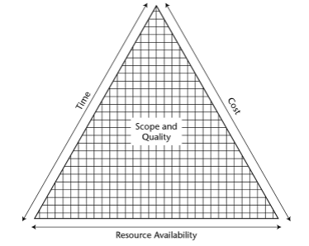

Figure 1: Scope Triangle

(Jennifer Greene, 2012)

The figure above describes the dependencies of the five constraints and how they affect each other (Groot, 2014). The arrows indicate change in all direction when there is a change in one constraint. Project plan describes the balance in these constraints before the beginning of the project but the change is bound to arrive once the project starts. The project manager controls resource utilization and work schedules. Management controls cost and resource level. The client controls scope, quality and delivery dates. Scope, quality, and delivery dates suggest a hierarchy for the project manager as solutions to accommodate the changes are sought (Roberts, 2015).

## **2.3 History of Project Management**

According to (Dinsmore, 2014), Project Management has been practiced ever since, thousands of years ago, since the Egyptian era, although, it has been just few decades back since the organizations have started to use this idea of project management in a systematic manner. In the past, the principles of project management have been used by the large engineering and construction companies to manage large budget, schedule driven projects. Organizations like NASA and Department of Defence started using those principles since the 1960s. While it was only in 1980 when the manufacturing and software development sectors started to adopt and implement the project management practices.

During the early 20th century, companies utilized the best practices of project management; there was more understanding and acceptance among all levels of senior managers rather than the executives themselves. Some companies made fact-based decisions rather than hopeful decisions with the help of project management tools. There was a certain roadmap for a project to follow from start to finish in a systematic way. With the help of project management, the goals and aim of the project were set empowering the team members to make them happen.

As years moved, companies realized that project management was not a necessity anymore, it was a must. Now, virtually every companies and industry utilizes the best practices of project management. The gradual increase in use of project management could be seen in different eras, but at this time, it is not about adapting the new project management but it is more about the speed at which it can be done, and the speed at which the company adopts and implements the best practices of the project management.

The decision of project management is taken by executives but the recognition of it is made by the lower and middle level managers who are actually working on the project. Harold R. (Groot, 2014) has stated six driving forces leading to the need for project management as “Capital projects, Customer expectations, Competitiveness, Executive understanding, new project development, Efficiency and effectiveness”. Capital projects are examples of manufacturing companies where the project is huge or there are simultaneous project going on, which makes executives realize how cash and workers should be handled. Customer expectation could be the driving force in the companies where they sell their projects or services. In this case, the solution provided to the customer is never complete so there need to exist a superior project management practice because they are not selling the products but actually selling project management expertise.

Competitiveness could be a driven factor when companies get into trouble in market related to cost or quality of their products, or even internally when people realize that outsourcing is more beneficial in time and cost for the company.

Project management system could be a necessity to the organization where R&D activities are their main projects. Efficiency and Effectiveness could exist with any other driving forces in parallel. It is more important for smaller companies to be competitive in market during high periods and also to assist in determining capacity constraints.

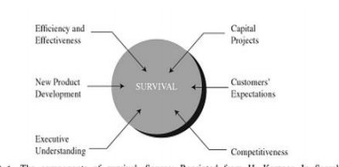

Figure 2: Components of Project Survival

(Groot, 2014)

A table to summarize the history of best practices of project management

|  |  |  |  |
| --- | --- | --- | --- |
|  | 1945-1960 | 1961-1985 | 1986-now |
| Customer Focus | Minimum  Profit driven  policies | Profit driven Policies. | Economic  Development of  International  Market. |
| Standardization of Practices | Over-the-fence  management | Wider use and implementation of project management due to market change. | Project  management  became a must  Standards were formed officially. |
| Market | War and post-war  economies | Economic  Development of  International  Market. | New markets  with change in  politics  Computer and e-driven  markets |

Table 1: History of Project Management

## **2.4 Project Management Software**

Although project management has been practiced for a long time now, it was not long ago when project management software was used for the first time. Early days of project management software was limited to the use in big mainframe computers and was used only in large projects. They had their own limitation in their capabilities and were also difficult to use. It could do the basic fundamentals of project management like planning, monitoring, controlling the project but as time and technology changed, the software got better. The larger and more complex the project, the greater will be the accrued benefits (Roberts, 2015)

These computer aided project management tools are capable of processing the large amount of information; they are capable of adjusting quickly to the changing project plans even at the execution phase. They are programmed so that they are capable of generating status reports for various levels of management and also providing possible alternative scenarios. As (Dinsmore, 2014)quotes “You should not be a slave to the system!” There are much available project management software but the chosen one should work for you to facilitate your work and you, as a project manager, should have a clear understanding about it and also have a clear understanding about the project requirements, project team and senior requirements.

“A 2006 survey of 753 project and program managers was conducted to rate several project management tools. Respondents were asked to rate tools on a scale of 1-5(low to high) based on the extent of their use and the potential of the tools to help improve project success. “Super tools” were defined as those that had high use and high potential for improving project success. These super tools included software for task scheduling (such as project management software), scope statements, requirements analyses, and lessons- learned reports.” (Andrew Stellman, 2014)

Examples of Project Management Systems that have been developed and their limitations are:

1. **Calligra Plan:**

This is among the first project management software to be constructed. It provides a user with features that allow them to be able to manage their projects within the project scope. The features that this project offers to the users are: bug tracking, time scheduling, resource management and workflow management. The limitation of this system is that it does not provide budget management, time tracing and invoicing (Groot, 2014).

1. **Endeavour Software Project Management:**

(Schwalbe K. ), Says that Endeavor Software Project Management System is one among the popular used systems in the world. The system takes account of the different project development phases and allows uses to be able to work according to the budget set. The limitation to this software is that it is not free, it is very expensive for organizations to purchase. The system is also complex for small project developers, and it requires training on how to use the system.

1. **Zoho Projects:**

This is a recent project management software created by the Zoho group. The system is efficient in allowing collaboration and bug tracking in the projects being developed. It is a web based system that allows users to be able to collaborate with their supervisors even when they are not near. The limitation of this system is that it has monetary features that require users to pay before they can be able to use them. Such features are: Budget Management, Time Tracking and Invoicing. The system does not provide efferent bug tracking in the different projects that are being developed (Institute, 2013).

1. **VIP Task Manager**

This is a client-server system which is suitable for small and midsize business, because of its rich tasks management capabilities. It has moderate shareware price which is transparent and fair. There are no any hidden or additional payments, all one needs to do is to pay for the number of licenses they want (depending on numbers of their teammates) and they will get the single installation setup including client and server components. This tool is very easy in installation and use, so one doesn’t need any trainings, except for simple tutorials which can be found on-line and in PDF. One can also test out 30-days trial version to decide if this software justifies its earned value.

## **2.5 Organizational Needs**

Each project in a company is different from others and the application of project management differs with different projects, so every company develops its own policies and procedures for project execution. Jennifer Greene, in his book, states that the project management is most frequently used by one or two groups; first group are those performing the work and the second those overseeing the work (operator). Although, these two groups may have different reasons to use the software, it is essential that they get the maximum out of the computer aided project management to achieve maximum out of the project. Both the groups have common needs from a project management software, although, the output may be different for different groups.

The first important aspect in completion for a project is its schedule. Scheduling programs calculate the amount of time a project will take to complete, provided with the activities to be performed, length of each activity and the relationships between the activities. This is more beneficial when the projects are larger, as there may be lots of changes during the project, and with the help of these programs, it becomes easier to see the overall change in project once a parameter is changed. Besides its basic benefits, scheduling can also help to check the alternative methods, numerous activities can be tried and the most advantageous can be selected. Some scheduling programs also offer resource management, which enables to evaluate resource requirements as well as to determine the changes brought by hiring additional labour or acquiring additional equipment or resources. On the other hand, project manager are able to analyse his estimation of the project with the real progress of the project team and any uncertainty in the project could be solved without any delays. In case of delays, he can check at the consequences and study recovery plans or any alternatives if possible.

The other category is the database programs. Database programs enable everybody involved in the project to keep the historical record regarding the time, cost and resources of the project and also analyse the future estimation for similar projects. “Storing the data in easily retrievable form increases the organization’s ability to produce a rapid and accurate estimate (Institute, 2013). Accounting records through the conventional way could be time consuming and prone to mistakes; the database programs enables to retrieve data quickly and project manager could track the records related to the invoiced bills and paid costs.

With the aid of project management software, the summary of the project could be extracted as a handout with ease and in very little time and also in neat and concise format. If the computer tools are used and with the latest printing facilities, summary reports are easy to develop and those reports could be in different formats whether it be graphs and charts or visual presentations.

### **2.6 Benefits of Project Management**

(Dinsmore, 2014), Said that “It doesn’t matter if your business is small, medium or large, project management software will provide your business with management tool that you would require to manage the projects, tasks, time and the resources required. The five key functions of project management software are: Project Panning, Scheduling and Time allocation, Resource Allocation, Communication and Collaboration and Documentation. The benefits of a project management system are:

1. **Collaboration with the team in Real time**: With Project management systems, one can be able to communicate and interact with members in real time, hence ensure that a project is developed in the way that it was planned. Corroboration is enhanced in different ways by using these systems. Instant chat application is one of the most common ways in which participants in project management can be able to communicate through. Email systems can also be incorporated in these systems so as to aid in real time communication between project participants. Through enhanced collaboration in projects, users can be able to make decisions faster, and also communicate about the progress of projects.
2. **Tracking**: Project Management Software plays a vital role in monitoring the stages of project in-line with the time frame. This also let one to determine what is pending and what has been completed, hence reducing a lot of paper or email updates from the team to project managers. Project tracking features also enable project managers to know about the progress made in the projects, and also about the input of each user in the projects.
3. **Internal and External Communication**: The project management software builds a channel for communication concerning tasks & projects at ease by the ability to upload and share files, which is collaborated online and integrated with email for regular email updates. This makes it easier to communicate with the clients, business documents can be sent directly to the client through the project management software.
4. **Optimal Resourcing**: The Project Management Software ensures that the finest resources are employed on the right project by examining the skill level required to finish the project on a specific given time. By using the project management software the each resource would know, at any given point, all the information need to complete the project
5. **Budget Management**: (Snyder, 2015), Says that Budget is one of the most critical item in managing any project and also the future of the business depends on how well the budget is managed. The Project Management Software enables the managers to see the project budget, i.e. planned vs Actual and enable them to align the budget so that it works out well in the required manner.
6. **Optimized Decision Making**: Project Management Software enhance the decision making process by making all the information available at on place, hence making the decision making process more accurate and optimized.
7. **Document Sharing**: These software allows users to update delete, create and share project documents with ease without the need pf printing them. Participants in the project management can be able to see the projects documents once they are uploaded by others and make comments regarding the areas that they need to update them. Document sharing feature in these systems does not only aid in sharing the documents, but also in the safe keeping of the projects documents. This is because once the documents are uploaded, they are safe from loss of theft.
8. **Reporting capabilities**. With flexible report formats and the ability to quickly access needed data, project management software can keep tasks on schedule.
9. **Ability to manage risks and forecasting**: Knowing project risks, creating forecasts and tracking budgets are some of the biggest advantages of project management software.
10. **Intuitive to use.** Dashboard-based software requires little training to implement. Simple to use and easy to install, new project management software allows for quick ramp-up times.

### **2.7 Limitations of Project Management Systems**

1. **They are costly**: Most of the available project management software are very expensive to purchase, hence small businesses and learning institutions cannot be able to afford them so as to utilize the benefits that they bring along.
2. **They may complicate simple projects**: Project Management Software are not efficient in managing small project as they make them complicated, hence increase time and budget required to complete them. If a project manager becomes so reliant on the application that it becomes a prerequisite for basic office functions, it could produce a work environment that is dominated by chaos and conflict. Similarly, the misapplication of sophisticated project management software to projects that require a more basic solution can make the management task overly complex.
3. **Automated alerts slow down the execution of project processes**: The automated alerts from these systems always destruct the developers and make them to concentrate on the issues in the alert than continue developing the project. Most of those alerts are caused by minor issues that do not require immediate attention.
4. **General project management systems do not always meet the needs of an organization**. Organizations undertake project management I different ways, and this makes it hard for a general system to be able to meet all the needs of an organization. For school based project management systems, schools and departments carry out project management in different ways, thus making it hard to have one general project to manage all the projects. Thus, in order to address this issue, projects management systems have to be specific to the needs of a given organisation.
5. **Inflexibility**: So it is written, so it shall be. At least that's the attitude some people have regarding project management solutions. Business projects are highly fluid by nature as they require constant modifications and updating. People are always advised not to allow themselves or their team members to become so attached to the software that they are unwilling to make adjustments when needed.
6. **Access concerns**: Project management solutions offer the possibility of multiple user access. The most sophisticated versions of online (and some desktop) applications can enable access for dozens of users. The collaborative benefits of multi-user access are great. But one will also need to address access control concerns to avoid unauthorized viewing of sensitive project data.
7. **Providing a Snapshot**: When training new staff members and introducing them to projects worked on by a company works, project management software offer a snapshot of the project which can be shared to get new staff up-to-speed. The snapshot allows one to show employees the project from start to finish, thus giving them background information and how the project will move forward.

## **2.8 Requirements for a Project Management Software**

In conclusion, after studying the materials related to project management and project management software, the authors present the summary of requirements for a project management software in this section. These requirements also act as the criteria for this thesis, and set up the basis for evaluation of the chosen software in the next stage.

Dinsmore has discussed and analysed the capability of computer aided project management to fulfil the needs of project management from the view point of project manager, the project itself, the project team and the senior management.

Project manager manages different projects in different style. In some cases, the details of project are highly covered in the system database and are readily accessible all times; the system is expected to process a large amount of data in short time. While, there could be cases where the project details are entered into the system but the project manager does not access it until it is required, providing more freedom for project team to work on their plans. The third style provided by Dinsmore explain about the low details into the system database and also low accessing the data, allowing the project team to work on their own without needing them to provide details to the system. And the last style involves highly responsive program capable of providing summary of the project without much details of the project. These are just generalized style and it is in the hand of the project manager and the team to choose whatever style is comfortable to them.

Furthermore, the issues of schedule, cost, physical parameters and visibility must be taken into consideration. The software need to have strong planning and monitoring capabilities if there is lack of input at a planning phase and also if the project is working on a tight budget. Projects are looked differently by different people at various positions. The owner might want to have an overall look of project without getting onto every detail, and also looking at various projects. While the engineer of the project is more concerned with the designing phase of the project and want to have a detail look and build the project. There may be general issues like compatibility with the current system, ability to track different projects and sub tasks, and also ability to forecast the required labour and resources may stand out for specific projects.

The software is just a medium for project success; it is in the combination of people in a project that decides for the project result. A project team having highly experienced members does not depend much on the software, while if the team members have low project management experience, they need to have program that could provide them details regarding project plan and also are able to track the details. The computer aided project management should act as interface between team members, as there need to be constant interactions between members. The system needs to plan and track the milestones agreed by team members in order that the project proceed as planned. On the other hand, senior management needs the system to provide them with summary information including key schedule deadlines, cost forecasts and corrective action scenarios or records or corrective action taken.

### **2.9 Recommendations**

Pertaining to the above literatures, there is need to develop and implement a cheaper project management system that will aid in simplifying the process of software development process and also guide the students through the different stages that are involved in project management and design and also guide them about the different deliverables that they are supposed to have at the end of each stage.

# CHAPTER THREE

## **METHODOLGY**

### **3.1 Agile Methodology**

Agile methodology was used to develop the system. Agile methodologies embrace iterations. Small teams work together with stakeholders to define quick pro-to types, proof of concepts, or other visual means to describe the problem to be solved. The team defines the requirements for the iteration, develops the code, and defines and runs integrated test scripts, and the users verify the results. Verification occurs much earlier in the development process than it would with waterfall, allowing stakeholders to fine-tune requirements while they’re still relatively easy to change. Consider the following diagram;

**Project approval**

Post-iteration consolidation

Iteration wrap-up

Iteration

Planning

Pre-iteration planning

Iteration execution

Figure 3: Agile process Release

Agile methodology is made up of **scrum** and **extreme programing (XP) methodologies**. The methodology to be used in this project is Scrum since extreme programing is meant for developing object based systems. Scrum for software development came out of the rapid prototyping community because prototypes wanted a methodology that would support an environment in which the requirements were not only incomplete at the start, but also could change rapidly during development. Unlike XP, Scrum methodology includes both managerial and development processes.

### **3.2 Scrum management**

At the centre of each Scrum project is a **backlog** of work to be done. This backlog is populated during the planning phase of a release and defines the scope of the release. After the team completes the project scope and high-level designs, it divides the development process into a series of short iterations called **sprints**. Each sprint aims to implement a fixed number of backlog items. Before each sprint, the team members identify the backlog items for the sprint. At the end of a sprint, the team reviews the sprint to articulate lessons learned and check progress. During a sprint, the team has a daily meeting called a scrum. Each team member describes the work to be done that day, progress from the day before, and any blocks that must be cleared. To keep the meetings short, the scrum is supposed to be conducted with everyone in the same room-standing up for the whole meeting.

When enough of the backlog has been implemented so that the end users believe the release is worth put-ting into production, management closes development. The team then performs integration testing, training, and documentation as necessary for product release.

### **3.3 Scrum development**

The Scrum development process concentrates on managing sprints. Before each sprint begins, the team plans the sprint, identifying the backlog items and assigning teams to these items. Teams develop, wrap, review, and adjust each of the backlog items. During development, the team determines the changes necessary to implement a backlog item. The team then writes the code, tests it, and documents the changes. During wrap, the team creates the executable necessary to demonstrate the changes. In review, the team demonstrates the new features, adds new backlog items, and assesses risk. Finally, the team consolidates data from the review to update the changes as necessary. The diagram below illustrates how scrum methodology works in development software;

|  |  |  |
| --- | --- | --- |
| **Pre- game** | **Mid –game** | **Post-game** |
| Planning and high level design | Review  Develop  Wrap  Adjust  Sprint review  Sprint plan | Close |

Figure 4: Scrum process

### **3.4 Strengths of agile methodology**

1. The Agile methodology allows for changes to be made after the initial planning. Re-writes to the program, as the client decides to make changes, are expected.
2. Because the Agile methodology allows you to make changes, it’s easier to add features that will keep you up to date with the latest developments in your industry.
3. At the end of each sprint, project priorities are evaluated. This allows clients to add their feedback so that they ultimately get the product they desire.
4. The testing at the end of each sprint ensures that the bugs are caught and taken care of in the development cycle. They won’t be found at the end.
5. Because the products are tested so thoroughly with Agile, the product could be launched at the end of any cycle. As a result, it’s more likely to reach its launch date

### **3.4 Weakness of agile methodology**

1. With a less successful project manager, the project can become a series of code sprints. If this happens, the project is likely to come in late and over budget.
2. As the initial project doesn’t have a definitive plan, the final product can be grossly different than what was initially intended.

Agile methodology was chosen for this project since the development of the system will involve various iterations and increments and also rapid changes. The methodology has many advantages compared to the other processes for this particular project e.g. waterfall etc.

### **3.6 Data Collection Methods**

The data collection methods to be used so as to make the project a success are:

#### **3.6.1 Observation**

This method of data collection will involve collecting data through observing the procedure and processes involved in project management in the school and other software development environments such as Software Technology Limited.

#### **3.6.2 Interviews**

This method will involve direct talk sessions with the staffs in the project development environments. The responses that I will get from them will aid me answering the question that I will have prepared before the interview.

#### **3.6.3 Document review**

This data collection method will entail reading through what has been written by others about project management. Through reading the books, journals and documents, I will be able get good in-depth information about project management and the areas that I will need to address.

### **3.7 Tools that will be used to Implement and Test the System were as follows with a detailed review of the tools in chapter four;**

1. **PHP:** Is a widely-used general-purpose scripting language that is especially suited for Web development and can be embedded into HTML.
2. **HTML5:** This is a hypertext mark-up language which allows the development of web applications. This is the latest version of HTTML.
3. **WAMP:** Is a free and open source cross-platform web server stack package(local server)
4. **MYSQL:** A relational database management system.
5. **Mozilla Firefox:** An Internet Browser.
6. **Yii2 Framework:** A free software that enhances the development process of a software.
7. **Bootstrap:** This is an open source css that allows web developers to develop mobile friendly web applications.
8. **Eclipse:** Is a free software development environment for PHP and other languages.

### **3.8 Data Analysis and Process Tools**

The data analysis and process tools we used include the following

Data Flow Diagrams (**DFD**), Entity Relationship Diagrams (**ERDs**), Flow chats, MS project, MS excel and Unified Modelling Language (**UML**) i.e. use case diagrams, sequence diagrams and activity diagrams (the tools are used in the system analysis and requirements modelling- chapter 4)

## **Time Schedule**

Thetime plan below shows the project time schedule from the start of developing iProject to the approximated completion date. The project was approximated to begin on 24th September, 2015 and end on 3rd April, 2016

**Project Time Plan**

|  |  |  |  |  |  |
| --- | --- | --- | --- | --- | --- |
| **S/No** | Activities | Estimated  Duration (Days) | Expected  Start Date | Expected End Date | Deliverable |
| 1 | Writing Proposal | 14 | 24th Sept | 4th Oct | Proposal |
| 2 | Data collection | 21 | 5th Oct | 26th Oct | Report |
| 3 | Literature review | 10 | 27th Oct | 4th Nov | Report |
| 4 | Analysis | 24 | 5th Nov | 29th Nov | Use case diagrams |
| 5 | Preliminary design | 23 | 1st Dec | 24th Dec | Class and sequence diagrams |
| 6 | Detailed design | 35 | 5th Jan | 10th Feb | Sequence, and package diagrams |
| 7 | Implementation | 28 | 11nth Feb | 4th March | Computer system |
| 8 | Unit testing | 5 | 6th March | 11th March | Test report |
| 9 | Validation testing | 5 | 12th March | 17th March | Validation report |
| 10 | Compile documentation | 12 | 18th March | 31st March | System documentation |
| 11 | Presentation | 3 | 1st April | 3rd April | Project Presentation |
| 12 | Write documentation | 180 | 24th October | 3rd April | Document Presentation |

Table 2: Project Time Plan

# CHAPTER FOUR

# SYSTEM ANALYSIS AND REQUIREMENT MODELING

## **4.1 Introduction**

Project management comprises of huge areas that need to be effectively managed so as to ensure that a project is successful. The major areas of project management are: scope, time and cost. These three areas needed effective management so that the project becomes as successful as it was planned.

Project managers are the guys responsible for managing projects and users involved in carrying out the different tasks in projects. Communication is vital for the success of a project. Most of the communication processes take place through written papers and emails. Written communication leads to loss of documents. Managers are also not able to communicate with all developers who have issues as they don’t have all the time to do that. This lack of efficient communication process leads poor outcomes of projects and project failure at times.

When a developer starts to develop a project, they write everything about the project on paper. In places where they have to make changes, they have to write a new document so that they can put the new added requirements. After they have collected all the information they need, they file them so that they don’t get lost. In cases where they have to start on other agent projects before they finish the ones they that they are working on, they start writing other documents separately.

Collaboration processes with other developers involves going to where the other developers are working and talking to them. In case developers want to involve them in them in their projects, they have to keep making journeys to and fro shifting desks.

The following diagrams represents the context diagram and data flow diagrams (**DFDs**) of how the current management process works

**Context Diagram showing how Project Management occurs**

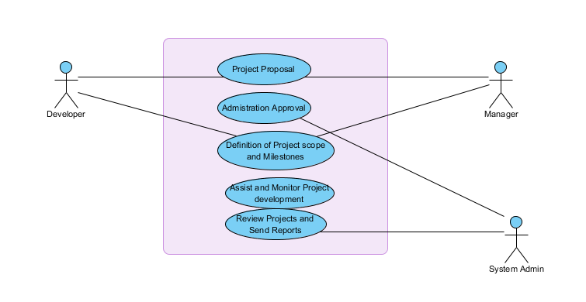

Figure 5: Context diagram for project management process

***A Flow Charts showing the current project management process is as shown below.***

Figure 6 Flow chat for project management process

Yes

No

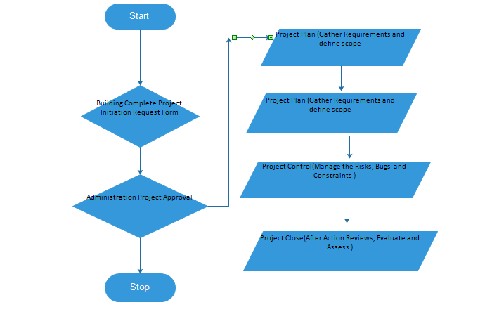

***DFD For the current system***

Student Details

Register

Student

Project Details

Project registration

Allocate supervisor to students

Admin

Supervisor

Student Mark

Supervisor

Manage Students

Figure 7: DFD for project management process

## **4.2 Feasibility Study**

***4.2.1 Technical Feasibility***

The technical requirements towards the development of the proposed system are readily available in the wide market. Proposed software to aid in the development of this project are: WAMP, ECLIPSE, MySQL and Yii2 Framework are readily available as open source software in the internet. This will enhance the software development process. There are also skilled software developers available and they will assist me in coming up with the software.

***4.2.2 Economic Feasibility***

The current project management processes are quite expensive as they are based on pure manual work. The cost incurred in filling and managing the project documents add to the cost of project management. Lack of a proper budget management process leads to waste of resources and this increases the cost of the overall project. Having a system that will aid in management of the different aspects of projects will aid in reducing the costs.

***4.2.3 Time Feasibility***

The proposed system will take a maximum of six months to develop and implement it. With the aid of a Gantt chat, it will guide me on how to develop the project sections within the proposed time. Having a project management system will allow developers to stick to their respective time schedules, hence deliver the projects in time.

***4.2.4 Operational Feasibility***

The approximated time for the development and management of projects varied from one project to another. The processes involved in project management are mostly delayed due to lack of proper communication processes between the project manages and the developers. This thus delays the operations of the project leading to wastage of time and resources.

## **4.3 Cost Benefit Analysis**

During the cost benefit analysis, the following costs and benefits was observed.

**Table 1: Cost Incurred to develop the iProject system**

|  |  |
| --- | --- |
| Activity | Cost (Ksh) |
| Development of the System | 90 100 |
| Procurement | 100 000 |
| Monthly operational Costs | 50 000 |
| Staff Training | 50 000 |
| Lifetime of the proposed system | 10 years |
| Total Life Time Cost | (90100+100000+50000+150000)*10 |
| **Total Cost** | **3 001 000** |

Table 3: Cost Incurred to develop the iProject system

**Table2: Benefits the iProject system is expected to yield**

|  |  |
| --- | --- |
| **Particulars** | **Benefits (KSH)** |
| Profits Incurred from on time delivery of projects | 200 000 |
| Savings from reduced running costs incurred in project supervision | 150 000 |
| Benefits incurred from a reduction in stationery equipment | 200 000 |
| Benefits from real time communication and budget management | 300 000 |
| **Total Benefits** | **850 000** |
| **Total Lifetime Benefits** | **8 500 000** |

Table 4: Benefits the iProject system is expected to yield

From the above tabulated cost benefit analysis, it is evident that the benefits outweigh the costs that will be incurred when developing the system. Thus, it is foreseen that the development of the iProject System is worth from as organizations will experience a high profit margin in the years that they will be using the system.

## **4.4 Fact Findings**

The fact finding study was carried out and the methods that were used to collect data included:

***4.4.1 Observations***

In this study, I observed the activities that take place in project management and I took note of the important aspects. I noted that organizations use different mechanisms when filing the project papers. They do this so that they can be able to account for every document that relates to a project. The filing methods used were also confusing to the managers and they were not comfortable with the manual system.

***4.4.2 Interviews***

In this fact finding technique, I was able to interact with project manager of different project and I had a chance to get firsthand information from them about the ways they carry put project management. I was able to ask them some of the leading questions that assisted me in understanding the way project management activities are carried out.

***4.4.3 Document Review***

In this technique, I went through some of the written documents regarding project management. Despite different authors giving different views on project management, one thing that was common was that project management was a complex area and there was need to have a system that could aid in ensuring that tasks are done in the right manner.

**Limitations of the above methods for data collection included:**

1. It took time to conceive some project managers and developers to give me information about how they carried out their activities. This is because some consider these activities are trade secrets that aid in enhancing their competitiveness.
2. It was difficult to understand the different filing and document management processes undertaken in project management.
3. I had limited time with the interviewees as they were in a hurry to go resume their duties.

## **4.5 Requirement definition and Modelling of the Current system**

It is in this stage, I modeled the requirements of the current system after having collected the analysis data for use in the development of the system to see how the current system operates. In order to come up with the requirement definition and modelling of the required system, I used

* Physical Data Flow Diagrams
* Logical Data Flow Diagrams

***4.5.1 Physical Data Flow Diagrams***

I used two physical DFSs to model the requirements of the current management process. This assisted me in establishing the kinds of the problems with the current process. These were:

1. **Document flow diagram**.

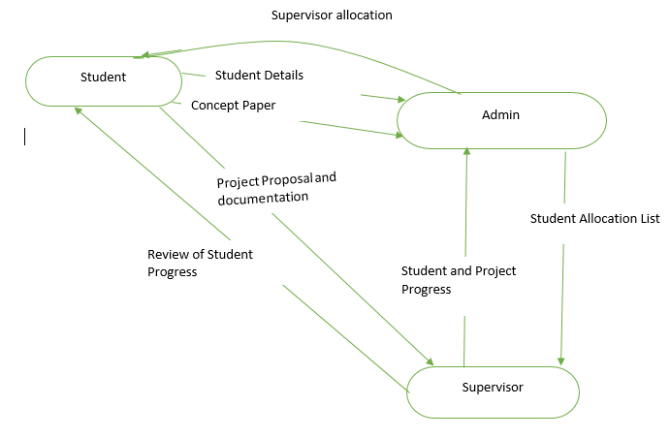

Figure 8: Document flow for project management

**process**

***4.5.2 Logical Data Flow Diagrams***

## **4.6 Requirement definition and specifications of the proposed**

This refer to the features that the proposed system is intended to have as per the user need specifications.

The Potential stakeholders of the proposed system are listed below:

* Project Managers (Admin)
* Project developers(Students and developers)

The stated user requirement are:

1. The system should allow manager to add project participants, i.e. developers.
2. The system should not discriminate any user irrespective of their contributing in the project management process.
3. The system should abide to the project management standards defined at the start of a project.
4. The system should allow document sharing and management.
5. The system should allow collaboration between developers and managers.

**The Following is a context diagram and a Use Case diagram for the iProject System.**

***Context Diagram***

Manage Projects, students, supervisors and review concept papers

Allocate supervisors

Register

iProject System

Student

Admin

Document management

Manage Complaints

Alerts on Project Progress

Student Proposal

Supervisor

Set deadlines, Send feedback on how students should organize their documents

Figure 9: iProject Context Diagram

***Flow Chart of the Proposed System***

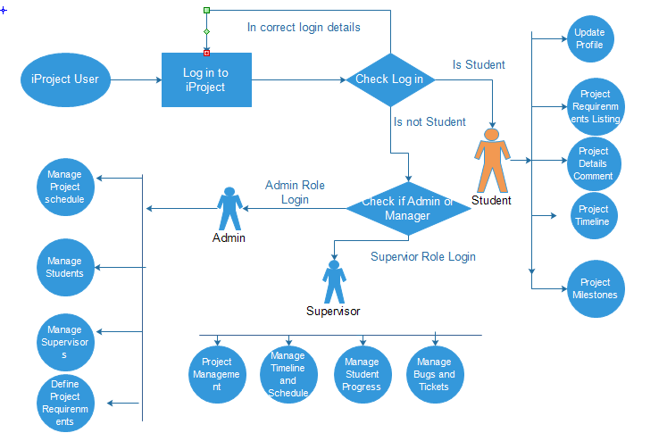

Figure 10: iProject Flow Chat Diagram

***Level 1 DFD of the desired system***

Student Details

Student Registration

Student

Milestone Management

Project milestone

Manage Documents

Project Documents

Manage Students

Admin

View Reports

Project Progress

Supervisor

Supervise Students

Student Marks

Figure 11: iProject Level 1 DFD

***Use Case Diagram***

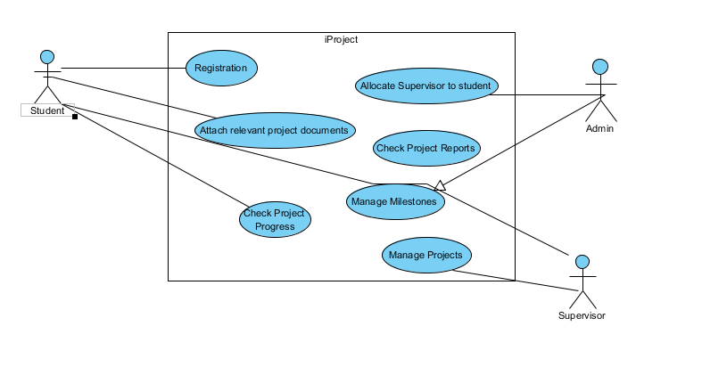

Figure 12: iProject Use Case Diagram

# CHAPTER FIVE

# SYSTEM DESIGN

After analysing and modelling of the current system and the proposed system requirements I embarked on designing the proposed system. In the design process I did a detailed design of the following sections;

1. File and data store design
2. Input design
3. Output design
4. Database design

## **5.1 File and data Store Design**

These are the objects that I used to store input data in the proposed computerized system. They are in tabular form. The main data that I accounted for in the design were:

* User Details.
* Admin details.
* Supervisor Details
* Project details
* Document Details
* User Profile Details
* Email Details
* Milestone Details
* Tasks Details

The following table shows the table design:

***Student Table***

|  |  |  |  |  |  |  |  |
| --- | --- | --- | --- | --- | --- | --- | --- |
| Student Reg No | First Name | Last Name | Email Address | Phone Number | User Name | Password | Date Create |
|  |  |  |  |  |  |  |  |

Table 5: Student Table

***Supervisor Table***

|  |  |  |  |  |  |  |
| --- | --- | --- | --- | --- | --- | --- |
| Supervisor ID | First Name | Last Name | Email Address | Phone Number | User Name | Password |
|  |  |  |  |  |  |  |

Table 6: Supervisor Table

***Admin Table***

|  |  |  |  |  |  |  |
| --- | --- | --- | --- | --- | --- | --- |
| Admin ID | First Name | Last Name | Email Address | Phone Number | User Name | Password |
|  |  |  |  |  |  |  |

Table 7: Admin Table

***Project Table***

|  |  |  |  |  |  |  |  |
| --- | --- | --- | --- | --- | --- | --- | --- |
| Project ID | Project Name | Project Type | Project Language to Use | Project Created Date | Project Expiry date | Project Business Unit | Project Area |
|  |  |  |  |  |  |  |  |

Table 8 Project Table

***User Profile Table***

|  |  |  |  |  |  |  |  |  |
| --- | --- | --- | --- | --- | --- | --- | --- | --- |
| User ID | User Status | User Hobby | User Date of Birth | User Location | User Occupation | User Pic | User Skills | User Sex |
|  |  |  |  |  | Student or Supervisor |  |  | “Male”, “Female” |

Table 9: User profile Table

***Document Table***

|  |  |  |  |
| --- | --- | --- | --- |
| Doc Id | Doc Name | Doc Created Date | Doc Type |
|  |  |  |  |

Table 10: Documents Table

***Email Details***

|  |  |  |  |  |  |
| --- | --- | --- | --- | --- | --- |
| Id | Receiver name | Receiver Email | Email Subject | Email Context | Attachment |
|  |  |  |  |  |  |

Table 11: Emails Details

***Task Table***

|  |  |  |  |  |
| --- | --- | --- | --- | --- |
| Task Id | Task Name | START Date | End Date | Resource (Person ) |
|  |  |  |  |  |

Table 12: Task Details

***Milestone Table***

|  |  |  |  |
| --- | --- | --- | --- |
| Milestone Id | Date | Milestone Type | Description |
|  |  |  |  |

Table 13: Milestones Details

## **5.2 Input Design**

The data stores and files that I designed earlier are supposed to contain data which will be useful to the to the iProject system user. I designed input forms that will facilitate the entry of data into the proposed system. These input forms will ensure that the users enter data accurately into the system. I designed the following input forms.

**Student Registration Form**

**Registration Number**

Registration No

First Name

Last Name

**Names**

Email Address

**Email Address**

Phone Number

**Phone Number**

Username

**Username**

Password

**Password**

Figure 13: Student Registration form

**Supervisor Registration Form**

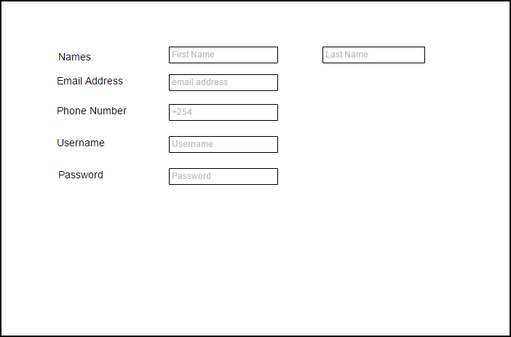

Figure 14: Supervisor Registration Form

**Project Registration Form**

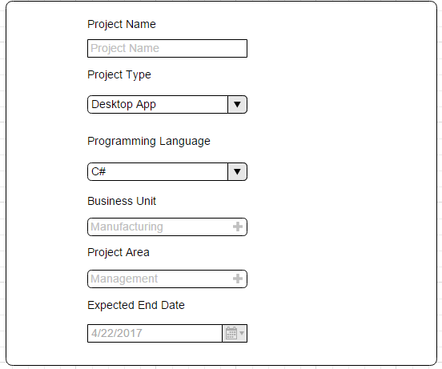

Figure 15: Project Registration Form

**Document Form**

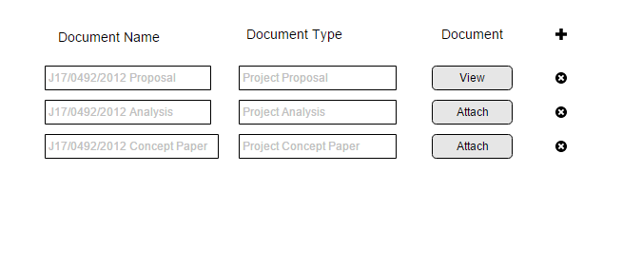

Figure 16: Project Document uploadform

**User Profile Form**

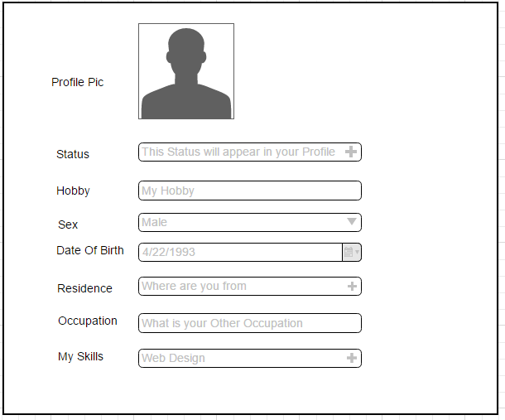

Figure 17: User Profile update Form

**Task Form**

Figure 18: Task Input Form

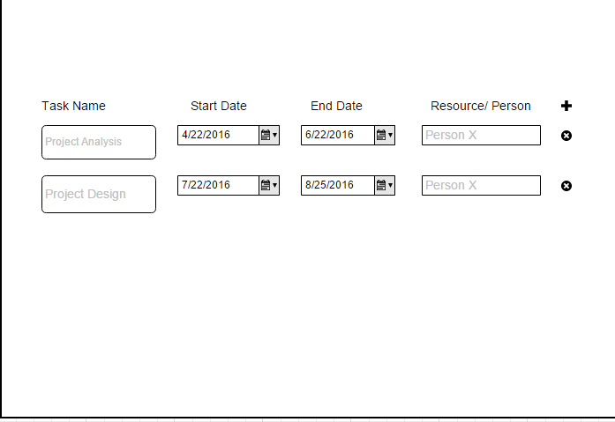

## **5.3 Database design**

Database design is the process of producing a detailed data model of a database. This logical data model contains all the needed logical and physical design choices and physical storage parameters needed to generate a design in a data definition language, which can then be used to create a database. In my database design I used phpMyAdmin and MySQL database management system (DBMS) to create the tables/relations and file structures and their relationships using the entity relationship diagram (ERD) which we used to store the iProject system information.

The following are the structural designs I constructed;

Table 14: Student Relation Structure

|  |  |  |
| --- | --- | --- |
| **Name** | **Data type** | **Field size** |
| Student_Reg | Varchar | 14 |
| firstName | Varchar | 30 |
| lastName | Varchar | 30 |
| emailAddress | Varchar | 30 |
| phoneNumber | Varchar | 15 |
| Username | Varchar | 20 |
| Password | Varchar | 20 |

Table 15: Supervisor Relation Structure

|  |  |  |
| --- | --- | --- |
| **Name** | **Data type** | **Field size** |
| supervisorID | Varchar | 11 |
| firstName | Varchar | 20 |
| lastName | Varchar | 20 |
| emailAddress | Varchar | 30 |
| phoneNumber | Varchar | 15 |
| Username | Varchar | 20 |
| Password | Varchar | 20 |

Table 16: Admin Relation Structure

|  |  |  |
| --- | --- | --- |
| **Name** | **Data type** | **Field size** |
| AdminID | Varchar | 11 |
| firstName | Varchar | 20 |
| lastName | Varchar | 20 |
| emailAddress | Varchar | 30 |
| phoneNumber | Varchar | 15 |
| Username | Varchar | 20 |
| Password | Varchar | 20 |

Table 17: Project Relation Structure

|  |  |  |
| --- | --- | --- |
| **Name** | **Data type** | **Field size** |
| supervisorID | Varchar | 11 |
| firstName | Varchar | 20 |
| lastName | Varchar | 20 |
| emailAddress | Varchar | 30 |
| phoneNumber | Varchar | 15 |
| Username | Varchar | 20 |
| Password | Varchar | 20 |

Table 18: Document Relation Structure

|  |  |  |
| --- | --- | --- |
| **Name** | **Data type** | **Field size** |
| Doc_ID | Varchar | 11 |
| Doc_Name | Varchar | 20 |
| Doc_Created_Date | Date | - |
| Doc_Type | Varchar | 50 |

Table 19: User Profile Relation Structure

|  |  |  |
| --- | --- | --- |
| **Name** | **Data type** | **Field size** |
| User_ID | Varchar | 11 |
| User_Status | Varchar | 20 |
| User_Hobby | Varchar | 50 |
| User_DOB | Date | - |
| User_Home_Location | Text | - |
| User Occupation | Text | - |
| User_Skills | Text | - |
| User_Sex |  | Male, Female |

Table 20: Email Relation Structure

|  |  |  |
| --- | --- | --- |
| **Name** | **Data type** | **Field size** |
| Email_ID | Varchar | 11 |
| Milestone_Name | Varchar | 20 |
| Receiver_name | Varchar | 50 |
| Receiver_email | Varchar | 50 |
| Email_subject | Varchar | 40 |
| Email_content | Text | 300 |
| Email_attachment | Varchar |  |

Table 21; Milestone Relation Structure

|  |  |  |
| --- | --- | --- |
| **Name** | **Data type** | **Field size** |
| Milestone_ID | Varchar | 11 |
| Milestone_Name | Varchar | 55 |
| date | Date | - |
| Description | Text | - |

Table 22: Tasks Relation Structure

|  |  |  |
| --- | --- | --- |
| **Name** | **Data type** | **Field size** |
| Task_id | Varchar | 11 |
| Task_Name | Varchar | 55 |
| Start_date | Date | - |
| End_date | Date | - |

After creating the relation structures I built an ERD which clearly show how the entities (an existing or real thing) relate to each other. The main components of an ERD are entities, relationships and their attributes. The ERD creates a graphical representation of the entities, and the relationships between entities, within an information system.

**The following is an ERD showing how the relations relate to each other.**

Figure 19: ERD Diagram

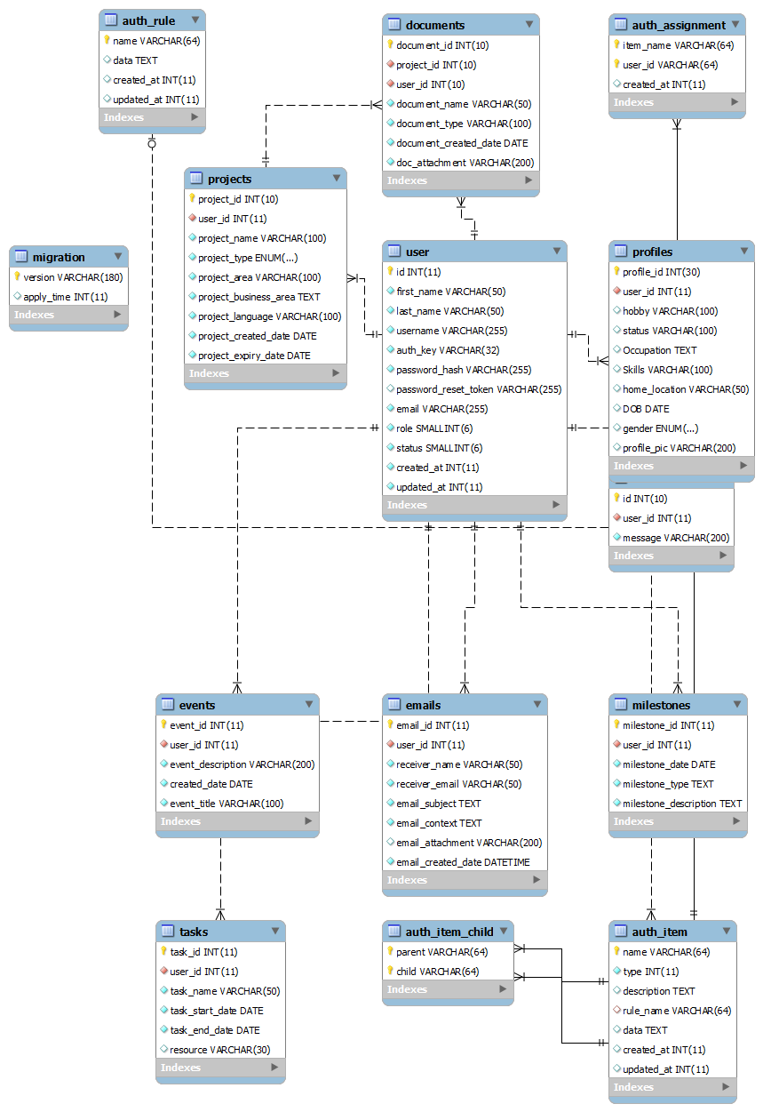

## **5.4 Output Design**

Output design involves the reports that are generated by a system. In our design of the iProject system I came up with the following output designs

**Project Report (Admin)**

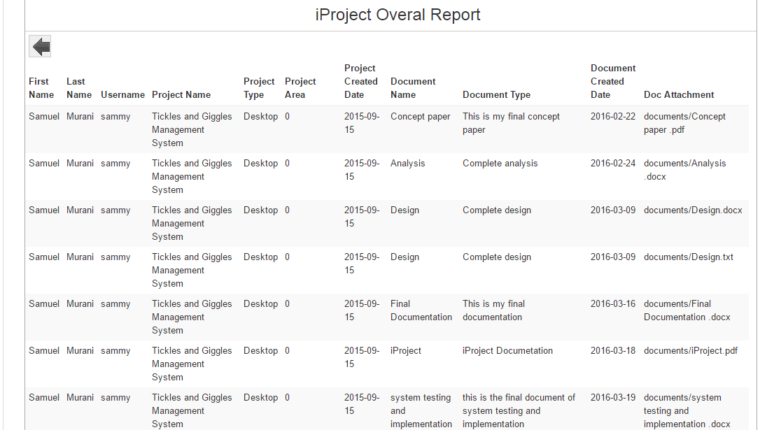

Figure 20: Project Report

Figure 21: System Users

**System Users**

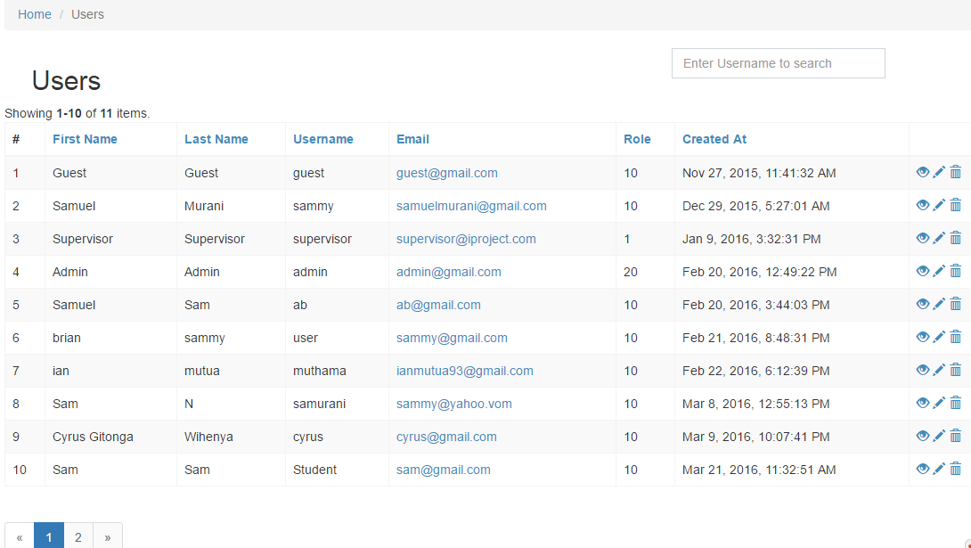

**Documents (Admin)**

Figure 22: Documents Report

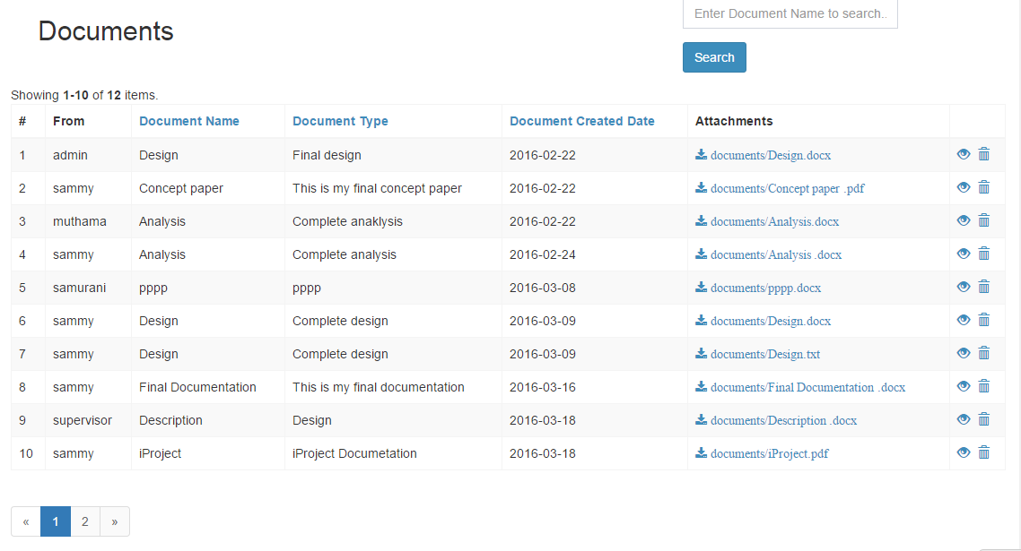

# CHAPTER SIX

# SYSTEM IMPLEMETATION

(Groot, M. e. (2014), defines system implementation as the construction of a new system and the delivery of that system into production so that it can be able to perform the day to day business activities it was indented to do. In this chapter, we involve ourselves into the construction of iProject Management system, testing it and finally deploying it so that it can serve its intended purpose.

## **6.1 Tools used for implementation**

The tools used for implementing iProject Management System included:

* **WAMP:** This is a free open source cross platform webserver stack package. It acts as a local server for hosting and running web based projects.
* **PHP:** This is an open source, general purpose scripting language that is especially suited for web development and can be embedded into HTML.
* **MySQL:** This is a relational database management system.
* **Chrome:** This is an internet browser.
* **Eclipse:** This is an open source web development tool and environment for developing web based applications, java and android applications.
* **Yii2 Framework:** This is a PHP based framework for faster, secure and efficient development of web applications.

**6.1.1 PHP**

PHP is the most popular general-purpose scripting language that is specifically suited for web development. This scripting language can perform any task that Computer Generated Imagery (CGI) program do, but its strength lies in its compatibility with many types of databases such as MySQL, Oracle, Mongo DB, etc. PHP also has the capability of talking across networks using IMAP, SNMP, NNTP, POP3, or HTTP.

***Why PHP was used***

We picked on PHP since it’s designed specifically for server-side programming, which means that its library is specialized for the tasks you'll be doing over and over again in the course of programming your website. PHP also has the advantage of being able to interweave code with HTML, thus allowing you to mix layout with other programming languages.

PHP is available for most operating systems including UNIX and Windows, and is an excellent server-side programming language for professional programming. PHP is still the easiest language to learn for non-technical people: it allows anyone to create dynamic websites faster than with any other technologies, it allows anyone to host websites cheaply and without any hassles.

***Limitations of PHP***

Despite PHP being an excellent web programming language, it has some security limitations. Web programming (regardless of language) is open to security flaws due to unimplemented or unknown vulnerabilities, takes a bit more caution.

**6.1.2 MySQL**

This is a Database management System (DBMS) that we used to create, modify, delete and modify the iProject database. We decided to use this Database Management System because it is the world’s second most widely used open-source Relational Database Management System (RDBMS). MySQL has phpMyAdmin embedded in it which provides a Graphical User Interface (GUI) which is user friendly. More so it is developed in PHP which in turn is easier to use. MySQL provides an SQL (structured query language) which includes Data Definition Language (DDL) and Data Modification Language (DML) which helps the programmer to query a database and gets an instant result concerning a particular data or rather an entity.

***Some of the benefits offered by MySQL are:***

It's fast: In the interest of speed, MySQL designers made the decision to offer fewer features than other major database competitors, such as Sybase* and Oracle*. However, despite having fewer features than the other commercial database products, MySQL still offers all of the features required by most database developers.

1. It's **scalable**: MySQL can handle almost any amount of data, up to as much as 50 million rows or more. The default file size limit is about 4 GB. However, you can increase this number to a theoretical limit of 8 TB of data.
2. It **manages memory efficiently**: MySQL server has been thoroughly tested to prevent memory leaks.
3. It's **secure**: MySQL includes solid data security layers that protect sensitive data from intruders. Rights can be set to allow some or all privileges to individuals. Passwords are encrypted.
4. It's **inexpensive**: MySQL is included for free with NetWare® 6.5 and available by free download from MySQL Web site.
5. It **runs on many operating systems**: MySQL runs on many operating systems, including Novell NetWare, Windows* Linux*, many varieties of UNIX* (such as Sun* Solaris*, AIX, and DEC* UNIX), OS/2, FreeBSD*, and others.
6. It **supports several development interfaces**: Development interfaces include JDBC, ODBC, and scripting (PHP and Perl), letting you create database solutions that run not only in your NetWare 6.5 environment, but across all major platforms, including Linux, UNIX, and Windows.
7. It's **easy to use**: While a basic knowledge of SQL is required—and most relational databases require the same knowledge—MySQL is very easy to use. With only a few simple SQL statements, you can build and interact with MySQL.
8. It **supports Novell Cluster Services**: MySQL on NetWare runs effectively with Novell® Cluster Services™, letting you add your database solution to a Novell cluster. If one server goes down, MySQL on an alternate server takes over and your customers won't know that anything happened.

***Limitations of MySQL***

The major limitation of MySQL DBMS is that it cannot be able to support a large database efficiently.

**6.1.3 WAMP (Window Apache MySQL and PHP)**

This is a free, open wen server solution stack package, which consists of mainly Apache HTTP Server, MySQL database and interpreters for scripts written in PHP programming language. We were motivated to use WAMP by a number of reasons which include.

1. It is easy to install.
2. It allows one to do tests, troubleshooting, demo or almost anything without the worries of the real website being touch.
3. It allows one to run many websites locally on the computer without any cost because the WAMP itself is free.
4. After successful testing, troubleshoot and so on, one can proceed to install or move it to the real server.

***Limitations of WAMP.***

The only thing to be careful of, when using WAMP, is a result of it being developed for developers to use in a development environment. Because the developer needs to be able to do anything during development, without needing to change settings, WAMP comes with all options turned on, and little in the way of the security that would be required in a live environment.

**6.1.4 Eclipse**

This is an integrated development environment (IDE). It has a base workspace and extensible plug-in system for customizing the development environment to meet user needs. It is free and open IDE, and it’s available for all platforms such as windows, Linux, Mac and etc.

**6.1.5 Chrome**

This is the browser that we used to test iProject Management System. It is free and open source web server developed for Linux, Windows, and OS X and for Android by google foundation.

## **6.2 Testing of iProject Management System**

***6.2.1 Unit Testing***

This is the approach we used to test iProject Management System so as to ascertain that it meets user needs specified in chapter four. This involved testing units (parts) of the developed system independently.

The problem stated in chapter 1 was broken down into several tasks. All of the stories and corresponding tasks were written down on paper that served as the only source of design documentation for the application.

While developing each task, Unit test suites were written to drive the development of user requirements.

No formal test plans were developed. The testing was primarily based on the tasks for future development. The development team got immediate feedback from the test team. Having the test team create the quick start samples gave the development team a perspective on the real-life usage of iProject Management system.

**How Testing was undertaken**

IProject has several modules. Some of the modules include:

* User Module.
* Projects Module.
* Documents Module

**User Module**

After the user module was completed, it was tested to ensure that all users required registration before they could log in the system. This module is also responsible to the registration of new users into the project, and it was tested to ensure that users could sign up and log into the system.

**Project Module**

This module involved the processing of projects, for instance addition of a new project, and managing projects. After the development of this module, it was tested to verify its relevance to both the admin and student interfaces.

**Documents Module**

This module involved the development of functions that could allow users to upload documents to the system so that supervisors could be able to view them. It was tested to ascertain that it met its purpose.

After the task passed all of the Unit test cases and was complete, quick start samples were developed to showcase the functionality. The quick start samples demonstrated the usage of the application and were useful for further testing the code in the traditional way (functional and integration tests). Any discrepancies found in this stage were reported immediately and were fixed on a case-by-case basis. The modified code was tested again with the automated test suites and then was handed over to be tested again.

### **6.3 Change over Technique**

These are techniques used to convert from the current system to the proposed system. The proposed change over technique was parallel change over

***Parallel change over***

In a parallel changeover, the new system runs simultaneously with the old for a given period of time. Of all the techniques, this tends to be the most popular, mainly because it carries the lowest risk. If something goes wrong at any point, the entire system can be reverted back to its original state. A primary disadvantage in running two systems at the same time is higher costs. The parallel changeover process also can be quite time-consuming.

***Advantages of parallel change over***

Parallel operation is the safest and secure method of changeover as both the old and new systems are in operation. If the new system doesn’t work as expected the company can use the old system as the backup until appropriate changes are made to the new system.

***Disadvantages of parallel change over***

Parallel operation is the most expensive changeover method than any other methods. Because both the new and old system are in full operation and the employees have to work on both systems and the organization has to hire more temporary human resource to handle the extra workload such as data entry and other processes.

# CHAPTER SEVEN

# LIMITATIONS, CONCLUSION AND RECOMMENDATIONS

## **7.1 Limitations**

During the project development process, we encountered a number of limitations that rendered the system being not fully efferent as planned. Some of the limitations we encountered include:

**7.1.1 Tools for development**

Due to the change of technology the development tools were new to the developers and thus it took them quit some tome to cope. Some of the tools were expensive to acquire since they were not locally available.

**7.1.2 Financial problems**

The system initial cost was too high. Many of the stakeholders suffer from Luddite syndrome hence it was a difficult task to convince them to hand in capital hoping that the current system they had could still accomplish their due tasks. Some employees feared to lose their jobs due to the introduction of a computerized system.

**7.1.3 Time management**

Since the project was a team work most of the work was stagnant since some developers were engaged with other activities aside from the development work

**7.1.4 Internet problems**

Time to time the network was not available. We had to wait for some time before it was up. As result the resources were scarce.

**7.1.5 User Training**

It was a hard task to train the users on how to use the system since most of them were computer illiterate which took some days to train them.

**7.1.6 Misunderstandings among developers**

Since the project was one done in group some members wanted to dominate on most of the development sessions which led to a huge misunderstanding.

## **7.2 Recommendations**

It is recommended that before developing any new system it is the responsibility of the developers to clearly understand the user’s requirements before imitating a project. Many projects have issues which lead to huge losses. It is simply good business practice to collect, process, and store, retrieve, and analyses data from pavement management and related systems to evaluate new materials concepts, techniques and designs. This is clearly illustrated in this study and by many of the references cited in this report. This report has only investigated on the primary benefit of having a project management system; it has not made an assessment of the market demand or marketability of this product. It is recommended that these factors be assessed. Market demand should be quantified and analyzed against purchase of products from suppliers and set-up costs in order to establish the optimal scale of purchasing the products. Further research is required to establish the students’ needs and wants so as to improve the project development process and make supervisors have an easy time when dealing with their students.

## **7.3 Conclusion**

This report has discussed the development of iProject Management System and how it can be utilized to perform project management activities. The objectives of this project were to;

Both objectives were met. Therefore it was concluded that project management is a challenging area that requires the need of a software to assist in the management of the tasks involved. The objectives of this project were:

1. To develop a user friendly system that will allow users to be able to interact with it with ease.
2. To analyse the different needs that students will need so as to ensure that they are able to develop projects well from scratch to completion.
3. To implement a fully functional iProject system that will overtake project management when supervising students and other stuff in organizations.

All objectives were met. There for, it was concluded that project management is a complicated area, but with the help of a software, project management processes can be eased.

# References

***Books***

Andrew Stellman, J. G. (2014). *Applied Software Project Management.* Michigan: O'Reilly Media.

Commerce, O. o. (2014). *Prince2 Business Benefits through Project Management* (3rd ed.). United Kingdom: The Stationary Office. .

Dinsmore, P. C. (2014). *Human Factors in Project Management* (4th ed.). New York: American Management Association.

Groot, M. e. (2014). *Project Management in Progress: Tools and Strategies for the 20s* (3rd ed.). Amsterdam: Elsevier Science Publishers.

Jennifer Greene, A. S. (2012). *Applied Software Project Management.* New York: O'Reilly Media.

Murali K. Chemuturi, T. M. (2010). *Mastering Software Project Management: Best Practices, Tools and Techniques.* New York: J. Ross Publishing.

Schwalbe, K. (2014). *Information Technology Project Management* (3rd ed.). Boston: Cengage Learning.

***Journals***

Schwalbe, K. (n.d.). Introduction to Project Management. *Project Management, 12*(31), 32-45.

Snyder, C. (2015). How to manage a project . *A Project Manager's Book of Forms, 12*(32), 34-66.

Wysocki, R. K. (2013). *Effective Project Management: Traditional, Agile, Extreme.* Chicago: Wiley. *12*(31), 32-45.

***ELECTRONIC SOURCES***

Institute, P. M. (2013). *Flexibility On A Global Scale*. Retrieved May 25, 2015, from http://www.pmi.org/

Roberts. (2015). *Guide to Project Management*. Retrieved May 25, 2015, from https://books.google.co.uk

Dhawan, Aditya. History of Microsoft Project. November 21, 2011.

http://microsoftproject2010msp.blogspot.fi/2011/11/normal-0-false-false-falseen-us-x-none.html

(accessed October 11, 2015).

JIRA Documentation. n.d.

https://confluence.atlassian.com/display/JIRA/JIRA+Documentation (accessed

August,September,October 2014).

LeapFrog technology- About. September 2014. http://www.lftechnology.com/about/us

(accessed September 22, 2015).

Microsfot Project Server Components and Authentication. 2002.

http://msdn.microsoft.com/en-us/library/aa164600(v=office.10).aspx (accessed

October 2015).

Microsoft Project. 2014. http://en.wikipedia.org/wiki/Microsoft_Project (accessed

October 10, 2015).

Microsoft Project Review: Project Management Granddaddy Shows Its Age. March 12,

2013. http://blinklist.com/reviews/microsoft-project (accessed October 2015).

APPENDICES

# Appendix 1: User Manual

iProject is an internet based system that enables students and system developers to be able to communicate with their supervisors and project managers, with ease and also share documents.

**Loading the system**

On your browser, type on the URL the following “localhost/iproject”, without the quotes. One should make sure that wamp server is running. After loading the system, the following menu will appear.



**1.1 User Manual**

**1.1.1 User Registration**

1. Click on Developer login button, then sign up to iProject.
2. Fill in the registration form, and click resister on completion.

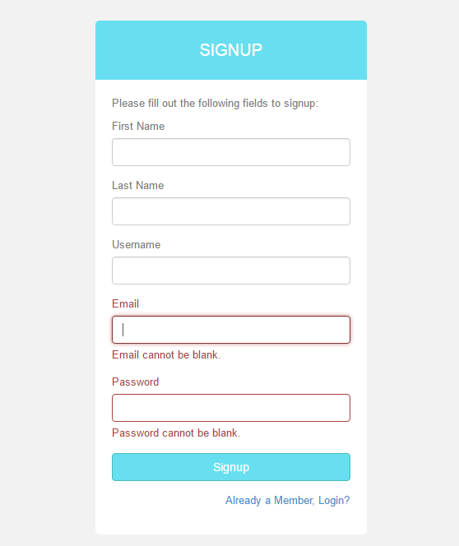

**1.1.2 Home Page**

On successful registration, you will be redirected to homepage.

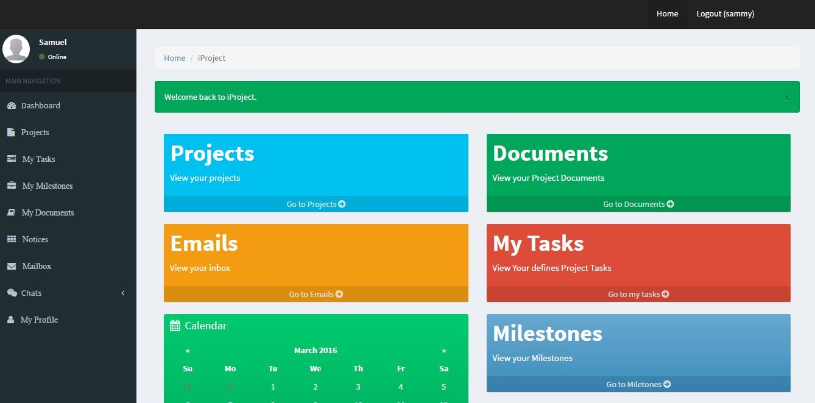

**1.1.3 Registering a Project.**

Registering a project is the first step to use iProject management system. Click on the Projects menu Items, in the Dashboard, and fill in the project details defined in the form labels.

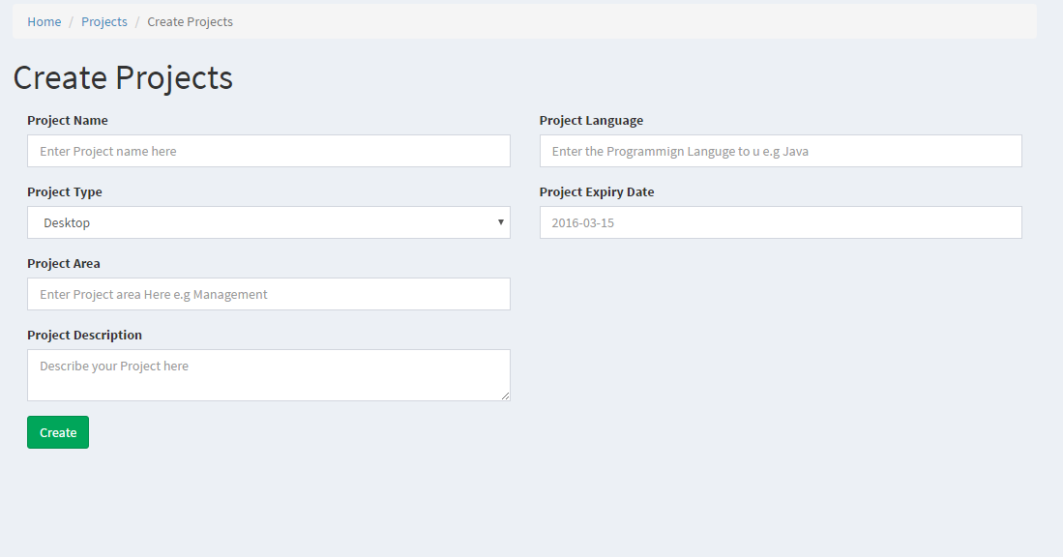

**1.1.3 Documents menu**

This section allows a student or developer to add project documents which they need to reach their supervisors. From the documents homepage, every new user is able to access a document from the supervisor, detailing the required documents needed and the dates. Uploaded documents are downloadable at any given time, thus once uploaded, the documents are secure. Documents marked in red are from the administrator.

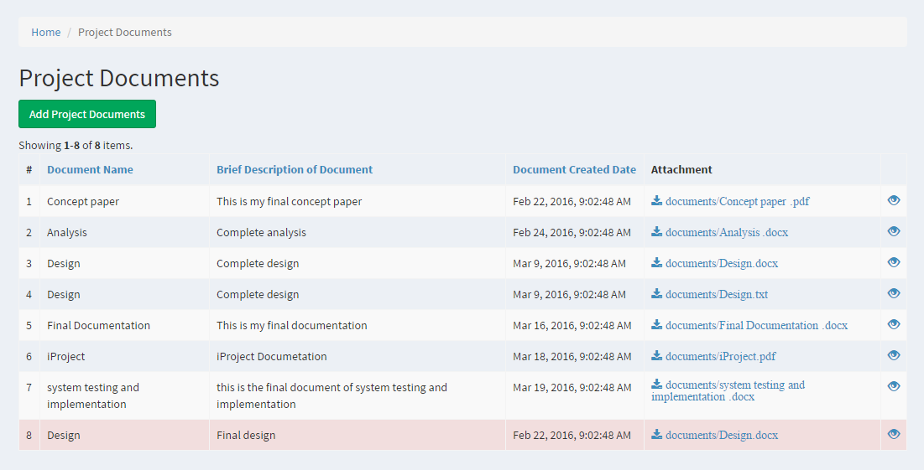

**1.1.4 Emails**

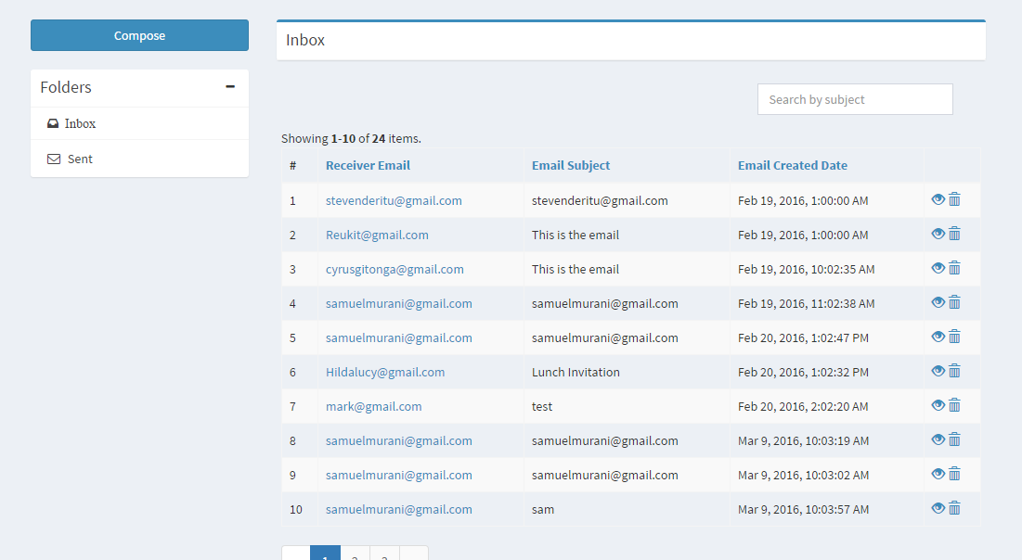

**1.1.5 Notices**

The notices section allows one to view notices sent by the supervisors. These notices are public to anyone using the system. Hence, the project admins can use the notices section to broadcast any information they wish to reach the developers of students.

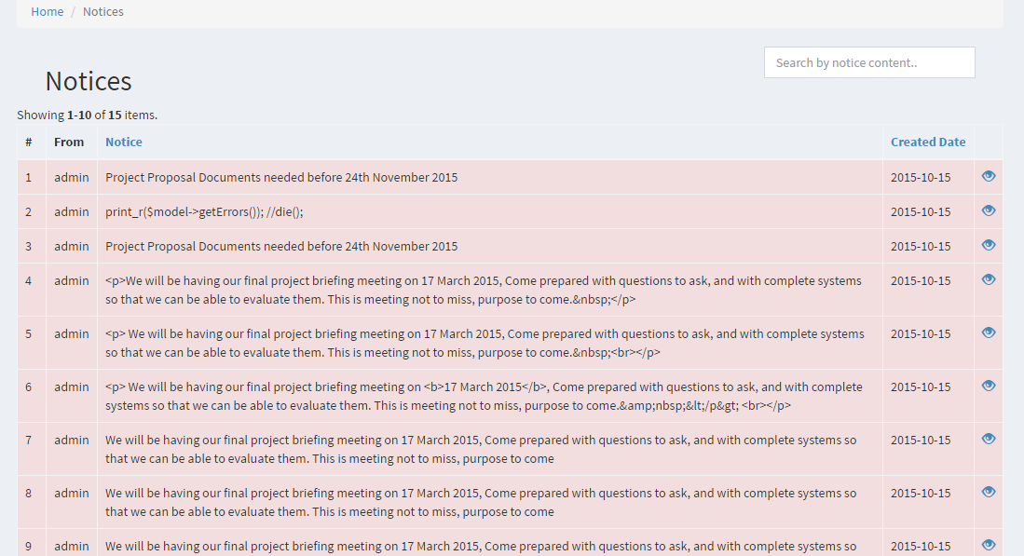

**1.1.6 Profile**

The profiles section allows a user to input their profiles details, including a profile pic, which can be used in their homepage.

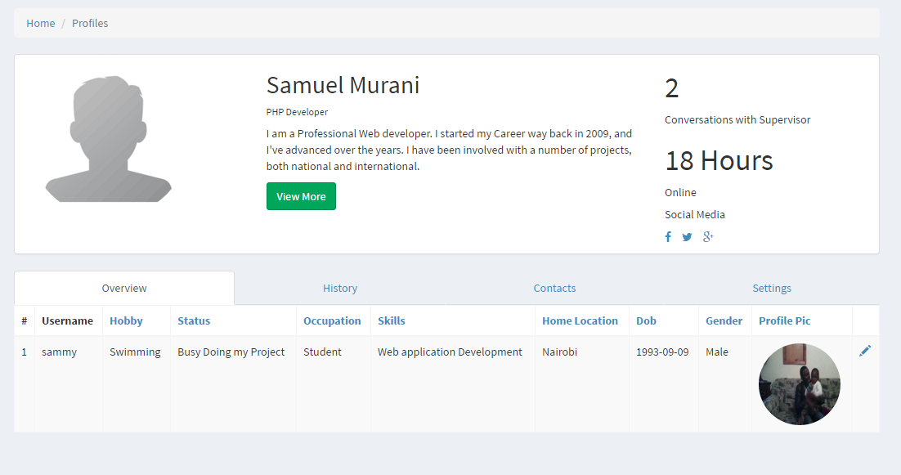

# Appendix 2: Project Cost (Budget)

It is anticipated that the total cost to be incurred in the development of the system will sum up to Ksh 90 100 as tabulated below;

|  |  |
| --- | --- |
| **ITEM** | **COST (KSH)** |
| Computer (i3 2.67 GHZ) | 65 000 |
| Printing and photocopying of necessary documents | 1000 |
| Note Books | 100 |
| Ball Pens | 100 |
| 4 GB Flash Disk | 1200 |
| Cost incurred during data and facts collection | 4000 |
| Secondary storage | 9000 |
| Airtel Modem | 2500 |
| Data bundles | 8000 |
| **TOTAL** | 90 100 |

**Table 3.0 Project Cost Estimation**

# Appendix 3: Time Schedule

The Gantt chart below shows the time schedule the entire project took from the start of developing iProject to the approximated completion date. The project was approximated to begin on 27th September, 2013 and end on 3rdnd April, 2016

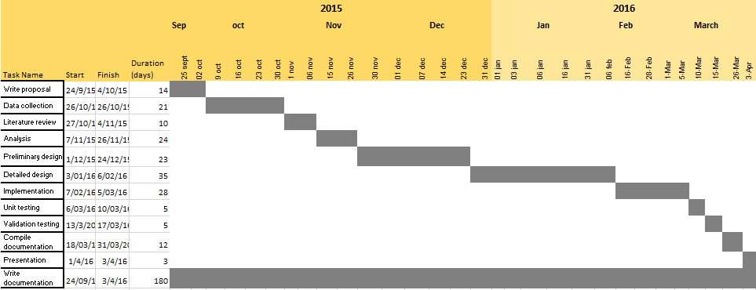

Table 1. Gantt chart

# Appendix 4: System analysis and requirement modelling symbols.

**4.1 Data flow diagram symbols and description**

|  |  |
| --- | --- |
| **Symbol** | **Description** |
|  | **Computerized process** |
|  | **Data flow** |
|  | **Decision** |
|  | **Disk transaction file** |
|  | **Manual input** |
|  | **Start/termination of program** |

**4.2 Unified Modelling Language (UML) symbols and description**

|  |  |
| --- | --- |
| **Symbol** | **Description** |
|  | **System boundary** |
|  | **Actor- individual/system that interacts with the main system.** |
|  | **Relation of an actor and the system** |
|  | **Use case** |

# Appendix 5: Sample database tables

**Table app. 5.1 User Table**

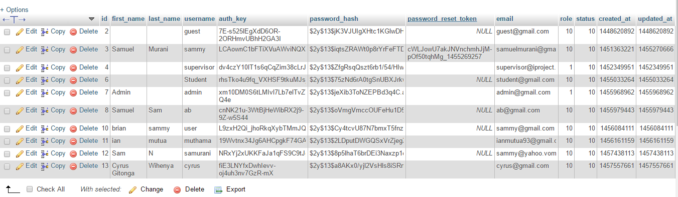

**Table app. 5.2 Documents Table**

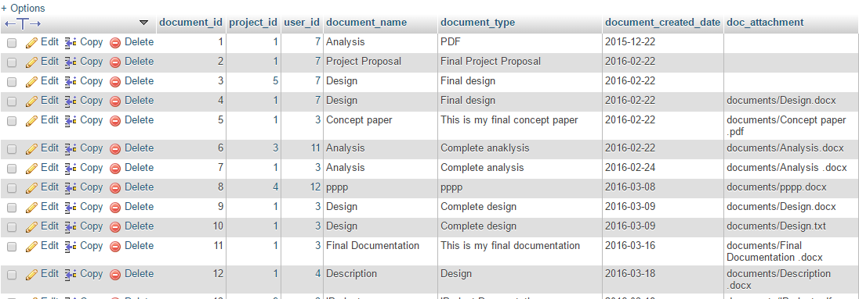

**Table app. 5.3 Project Table**

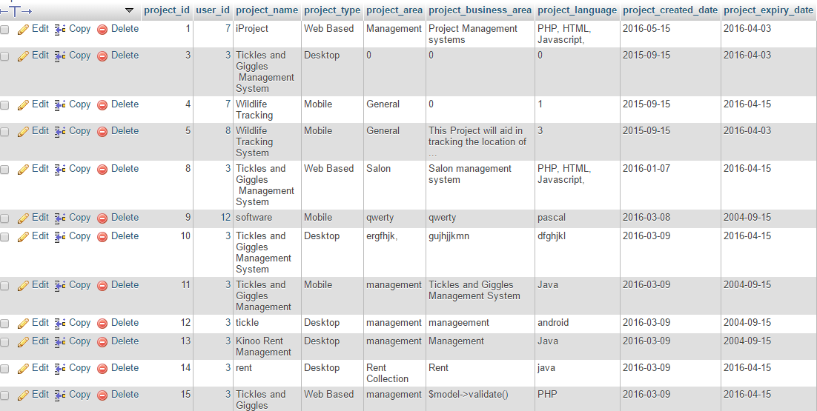

**Table app. 5.4 Emails Table**

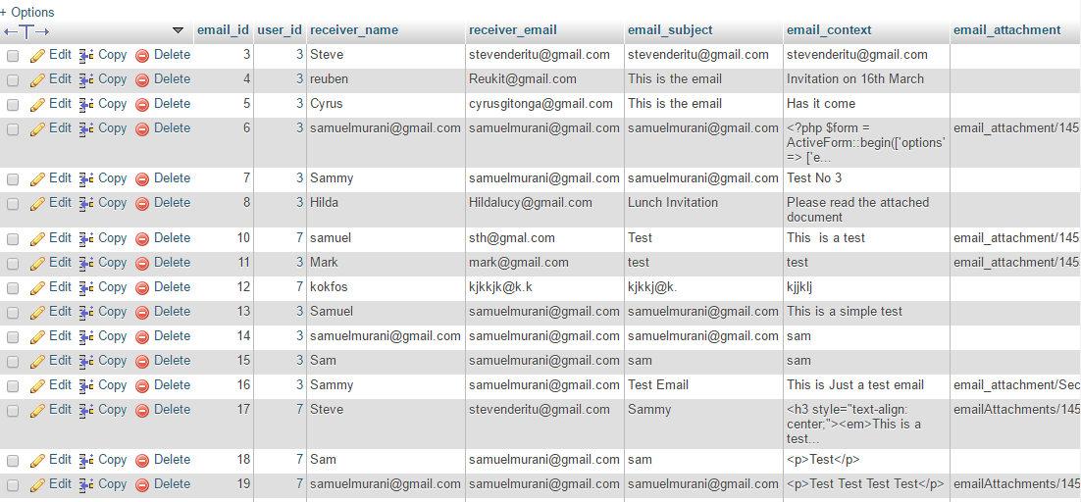

# Appendix 6: Some important source code for iProject.

**6.1 User Registration Source Code**

//The following code performs registration and saves user data in the database (Based on Model View Controller)

Sign up form (View)

<div class=*"row"*>

<div class=*"col-lg-5"*>

<div id=*"login-page"*>

<div class=*"container"*>

<div class=*"form-login"*>

<h2 class=*"form-login-heading"*>Signup</h2>

<div class=*"login-wrap"*>

<?php $form = ActiveForm::*begin*(['id' => 'form-signup']); ?>

<p>Please fill out the following fields to signup:</p>

<?= $form->field($model, 'first_name') ?>

<?= $form->field($model, 'last_name') ?>

<?= $form->field($model, 'username') ?>

<?= $form->field($model, 'email') ?>

<?= $form->field($model, 'password')->passwordInput() ?>

<div class=*"form-group"*>

<?= Html::*submitButton*('Signup', ['class' => 'btn btn-theme btn-block', 'name' => 'signup-button']) ?>

</div>

<label class=*"checkbox"*>

<span class=*"pull-right"*>

<?= Html::*a*('<data-toggle="modal"> <span>&nbsp; Already a Member, Login?</span></i>',['login']) ?>

</span>

</label>

<?php ActiveForm::*end*(); ?>

</div>

</div>

</div>

</div>

</div>

</div>

</div>

Controller

**public function** actionSignup()

{

$this->layout='LoginLayout';

$model = **new** SignupForm();

**if** ($model->load(Yii::*$app*->request->post())) {

**if** ($user = $model->signup()) {

**if** (Yii::*$app*->getUser()->login($user)) {

Yii::*$app*->getSession()->setFlash('success', 'Welcome to iProject where you get to manage all your projects.');

Yii::*$app*->getSession()->setFlash('danger', 'You currently have no projects, start by filling in details about your project .');

Yii::*$app*->getSession()->setFlash('danger', 'You currently have no project tasks, proceed to filling in details about your project tasks');

**return** $this->goHome();

}

}

}

**return** $this->render('signup', [

'model' => $model,

]);

}

Model

**class** SignupForm **extends** Model

{

**public** $first_name;

**public** $last_name;

**public** $username;

**public** $email;

**public** $password;

/**

* @inheritdoc

*/

**public function** rules()

{

**return** [

['username', 'filter', 'filter' => 'trim'],

['username', 'required'],

['first_name', 'required'],

['last_name', 'required'],

['username', 'unique', 'targetClass' => '\common\models\User', 'message' => 'This username has already been taken.'],

['username', 'string', 'min' => 2, 'max' => 255],

['email', 'filter', 'filter' => 'trim'],

['email', 'required'],

['email', 'email'],

['email', 'unique', 'targetClass' => '\common\models\User', 'message' => 'This email address has already been taken.'],

['password', 'required'],

['password', 'string', 'min' => 6],

];

}

/**

* Signs user up.

*

* **@return** User|null the saved model or null if saving fails

*/

**public function** signup()

{

**if** ($this->validate()) {

$user = **new** User();

$user->first_name = $this->first_name;

$user->last_name = $this->last_name;

$user->username = $this->username;

$user->email = $this->email;

$user->setPassword($this->password);

$user->generateAuthKey();

$user->save();

// $auth = Yii::$app->authManager;

//$authorRole = $auth->getRole('author');

// $auth->assign($authorRole, $user->getId());

**return** $user;

}

**return null**;

}

}

**6.2 Documents Source Code**

/The following code performs Document, creation, view, and deletion (Based on Model View Controller)

//Document upload form

<?php

$dataProjectname =ArrayHelper::*map*(Projects::*find*()->all(),'project_id','project_name');

?>

<div class=*"row"*>

<div class=*"col-lg-8"*>

<?php $form = ActiveForm::*begin*(['layout'=>'horizontal','options' => ['enctype' => 'multipart/form-data']]) ?>

<?=$form->field($model,'project_id',[

'horizontalCssClasses'=>[

'wrapper'=>'col-sm-4',

]

])->dropDownList($dataProjectname,

//ArrayHelper::map(Projects::find()->all(), 'project_id','project_name'),

['prompt'=>'--Select Project--']

) ?>

<?= $form->field($model, 'document_name',[

'horizontalCssClasses'=>[

'wrapper'=>'col-sm-6',

]

])->textInput(**array**('placeholder' => 'Eg Project Proposal'),['maxlength' => 50]) ?>

<?= $form->field($model, 'document_type', ['enableAjaxValidation' => **true**])->textInput(**array**('placeholder' => 'Corrected Project Proposal Document'),['maxlength' => 100]) ?>

<?= $form->field($model, 'file')->fileInput() ?>

<div class=*"form-group"*>

<?= Html::*submitButton*($model->isNewRecord ? 'Create' : 'Update', ['class' => $model->isNewRecord ? 'btn btn-success' : 'btn btn-primary']) ?>

</div>

<?php ActiveForm::*end*(); ?>

</div>

</div>

//Document creation Action

**public function** actionCreate()

{

$model = **new** Documents();

**if** ($model->load(Yii::*$app*->request->post())&& $model->validate()){

$imageName=$model->document_name;

$model->file=UploadedFile::*getInstance*($model, 'file');

$model->file-> saveAs('documents/'.$imageName.'.'.$model->file->extension);

//save path of image in the DB

$model->doc_attachment='documents/'.$imageName.'.'.$model->file->extension;

$model->user_id= Yii::*$app*->user->identity->id;

$model->document_created_date=date('y-m-d h:m:s');

$model->save();

Yii::*$app*->getSession()->setFlash('success', 'Your project documents were successfully saved.');

**return** $this->redirect(['view', 'id' => $model->document_id]);

} **else** {

**return** $this->render('create', [

'model' => $model,

]);

}

}

//Document Model Source Code.

**public** $file;

**public function** rules()

{

**return** [

[['project_id', 'document_name', 'document_type',], 'required'],

[['project_id', 'user_id'], 'integer'],

[['document_created_date'], 'safe'],

[['document_name'], 'string', 'max' => 50],

[['document_type'], 'string', 'max' => 100],

[['doc_attachment'], 'string',],

[['file'],'file', ]

];

}

# Appendix 7: Installation Manual

Instructions for installing WAMP, importing database and running the iProject System.

**7.1 installing WAMP and importing database**

1. Install WAMP using the **wampserver2.5-Apache-2.4.9-Mysql-5.6.17-php5.5.12-64b-** installer set up file from the DVD. After installation run WAMP control panel. From the control panel click the button labelled explore, a window will open with the path where WAMP is installed.
2. Move to the folder named www, and copy the folder named iProject from the DVD and paste it in this location.
3. Run the browser on your PC (Mozilla Firefox or chrome) in the URL address bar type in "localhost/" without the quotes ("").
4. Click on phpMyAdmin from the homepage of wamp. From the phpMyAdmin window click on the button labelled databases and then click on the button labelled import.
5. Click on the button labelled browse to browse where the database is saved (In the DVD, file named yiip.sql) and click on the Go button, the database will be imported to the phpMyAdmin.

**8.2 Running the iProject Management System**

1. Run the browser on your PC.
2. On the URL address bar type in "localhost/iProject/" without the quotes, the system opens from where you can create an account in order to access the system.

Enjoy our system; your business is our business!